St. Paul’s Church, 166 High Street, Newburyport, MA

Sunday, April 24, 2022 9:00 am

The Second Sunday of Easter

stpaulsnewburyport.org

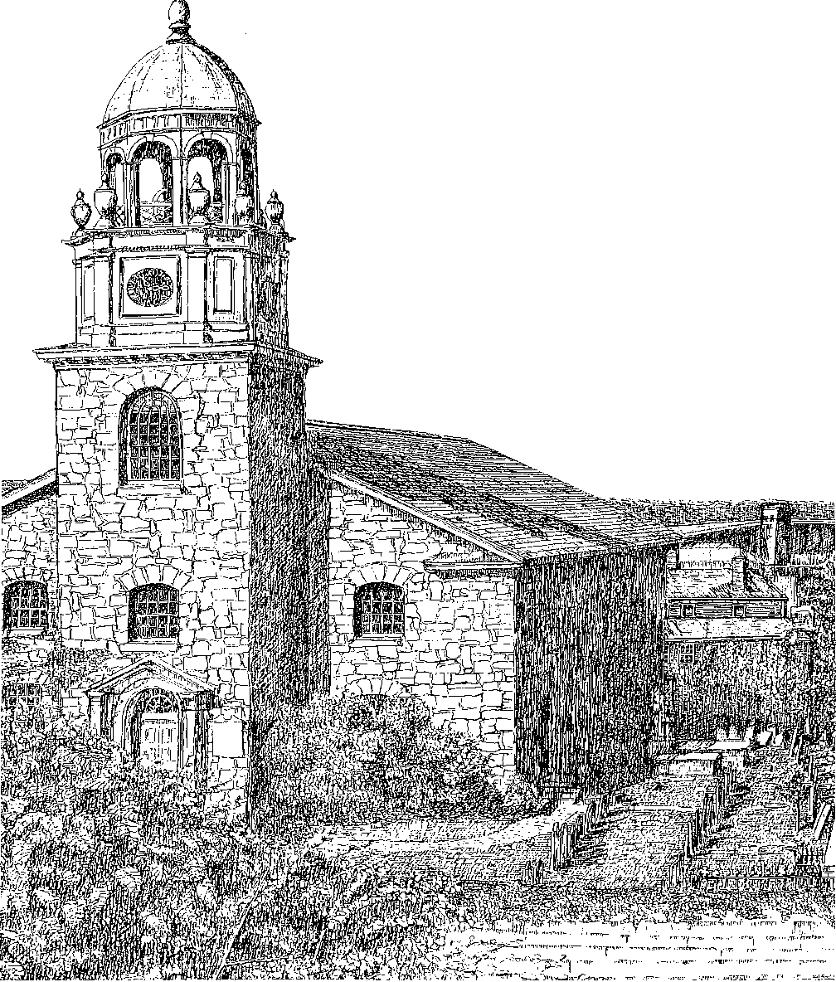

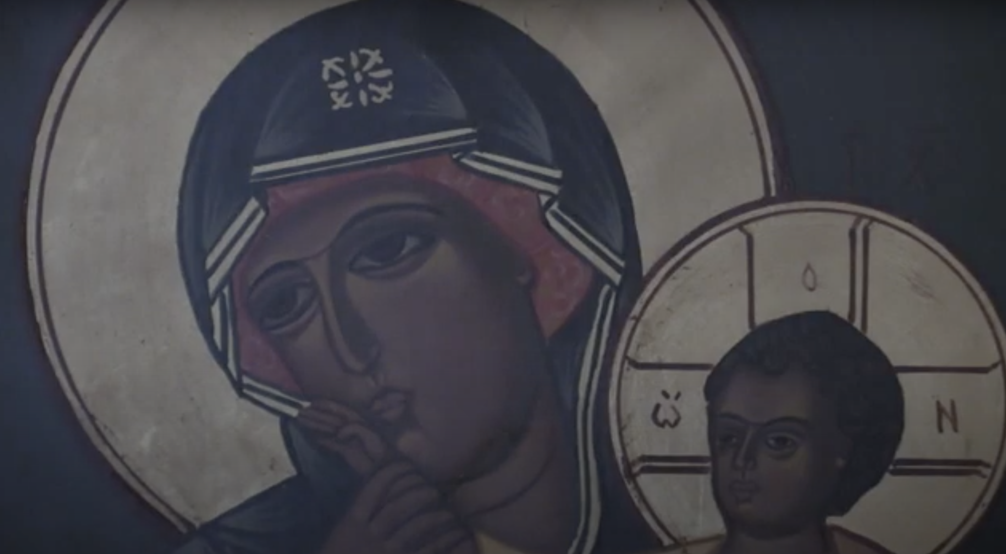
St. Paul’s Episcopal Church is an inclusive Christian community. It’s a community that takes God’s love for the world seriously, fosters a living faith, and cares for one another—it’s a community of belonging. We’re also a community that welcomes doubt as part of faith, values questions alongside answers, and provides a home for exploration, wherever you find yourself on the spectrum of belief and in your pursuit of truth.

At St. Paul’s we worship God, pray for our world, build community, and seek to serve others by working for justice, peace, and reconciliation. That work brings those who are vulnerable, rejected, overlooked, or marginalized in our world to the center of our life together. This is the story we embody every time we gather for the Eucharist, as we join in Jesus Christ’s offering of himself for the life of the world—Christ, who became the poor, marginalized, rejected one on the cross for our salvation.
Welcome Home

The Eucharist (also called the Mass or Holy Communion) is our share in that offering. It’s at the heart of everything we are and do, and so we celebrate it with reverence, solemnity, and great joy. The word Eucharist means “thanksgiving,” and in it we offer our whole selves to God in thanks—our frustrations and conflicts, our peace and joy, our sorrow and pain—and receive ourselves back anew, transformed by Christ’s presence. Like our Baptism, the Eucharist is a sacrament of unity. In it we are made a true community, united in love and service as the family of Christ.
The Eucharist is also a revolutionary act of justice and equality (as is our Baptism, through which we enter this family of Christ). In the Eucharist we, regardless of the color of our skin, our gender identity or sexuality, our age, our abilities, our social or economic status—people who in many places in our world would not be seen under same roof together—receive the same life-giving bread and call each other one body and one family. There is perhaps no more radical act in our world than this.
Through this offering of the Eucharist, we become a eucharistic gift ourselves, an offering of love and mercy to the world.

As we enter into and embody this story of God’s love, everything you need to follow along is in this booklet. Maybe you’re with us just for the day, maybe you’re getting to know us just a little bit more, but maybe, just maybe, you’ve found a home. If you’re interested in learning more about being baptized or becoming a member of St. Paul’s, or you have questions or need anything at all, please don’t hesitate to talk to me after the service or reach out any time.

Grace and peace,

The Rev. Dr Jarred Mercer (Fr Jarred)
Rector
www.stpaulsnewburyport.org

Prayers of preparation before the Eucharist

As you enter the church and are seated, take time in silence and prayer to prepare yourself for our worship together. Here are some prayers that may help.

Prayer Before Receiving Communion (Book of Common Prayer)

Be present, be present, O Jesus, our great High Priest, as you were present with your disciples, and be known to us in the breaking of bread; who lives and reigns with the Father and the Holy Spirit, now and for ever. Amen.

Anima Christi (Soul of Christ)

Soul of Christ, sanctify me.
Body of Christ, save me.
Blood of Christ, inebriate me.
Water from the side of Christ, wash me.
Passion of Christ, strengthen me.
O Good Jesus, hear me.
Within your wounds hide me.
Permit me not to be separated from you.
From the wicked foe, defend me.
At the hour of my death, call me
and bid me come to you
That with your saints I may praise you
For ever and ever. Amen.

The Beatitudes (Matthew 5:3–10)

Blessed are the poor in spirit, for theirs is the kingdom of heaven.
Blessed are those who mourn, for they will be comforted.
Blessed are the meek, for they will inherit the earth.
Blessed are those who hunger and thirst for righteousness, for they will be filled.
Blessed are the merciful, for they will receive mercy.
Blessed are the pure in heart, for they will see God.
Blessed are the peacemakers, for they will be called children of God.
Blessed are those who are persecuted for righteousness’ sake,
for theirs is the kingdom of heaven.

THE LITURGY OF THE WORD
Prelude: “O sons and daughters, let us sing” organ setting by Michael Burkhardt (b. 1957)
“Alleluia, alleluia! Give thanks” organ setting by Jacob B. Weber (b.1988)

Please stand as you are able.
Opening Hymn: “Come, ye faithful, raise the strain” #200 The Hymnal 1982
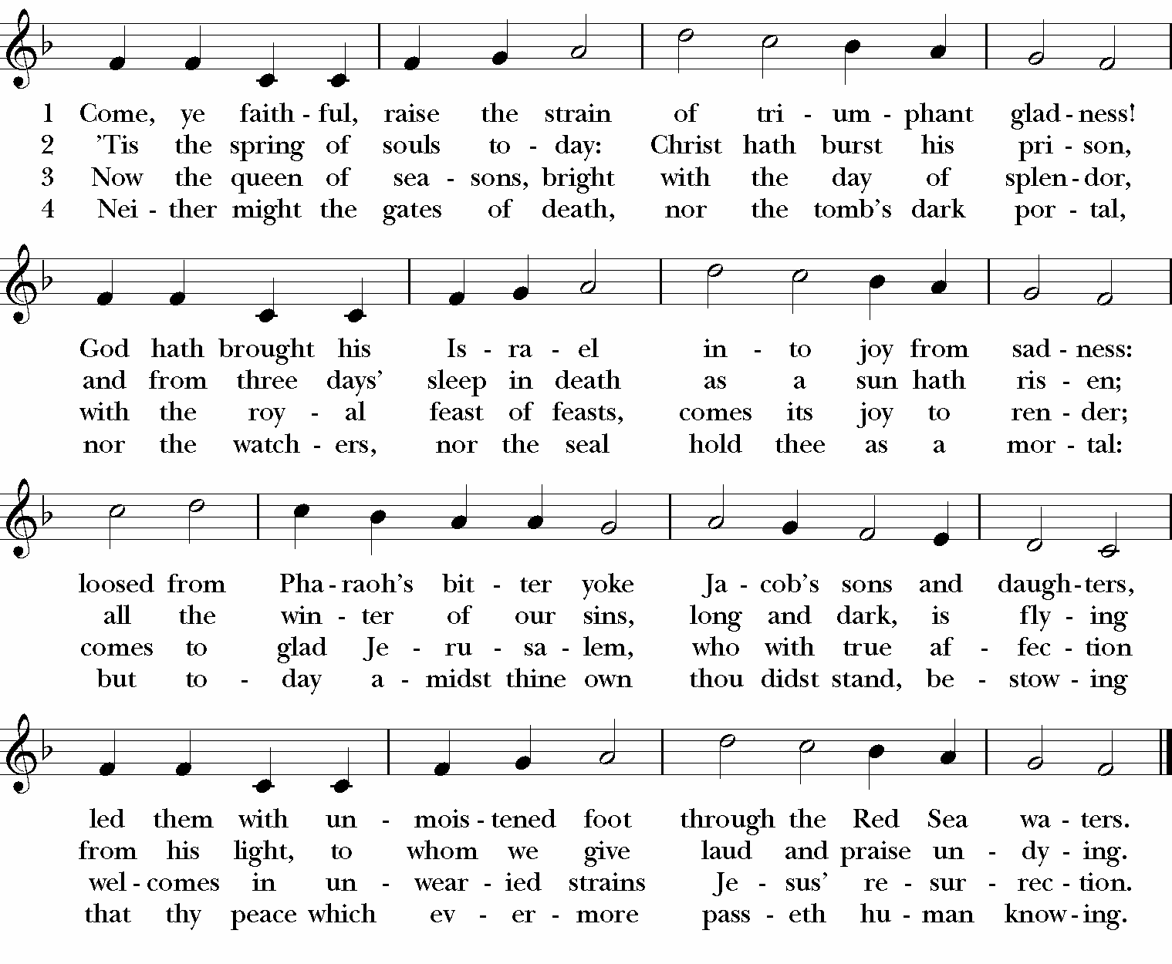
Opening Acclamation
Celebrant: In the name of the Father, and of the Son, and of the Holy Spirit.
People: Amen.
Celebrant: Alleluia, Christ is risen.
People: The Lord is risen indeed. Alleluia.

Gloria “Glory to God” S 280 The Hymnal 1982
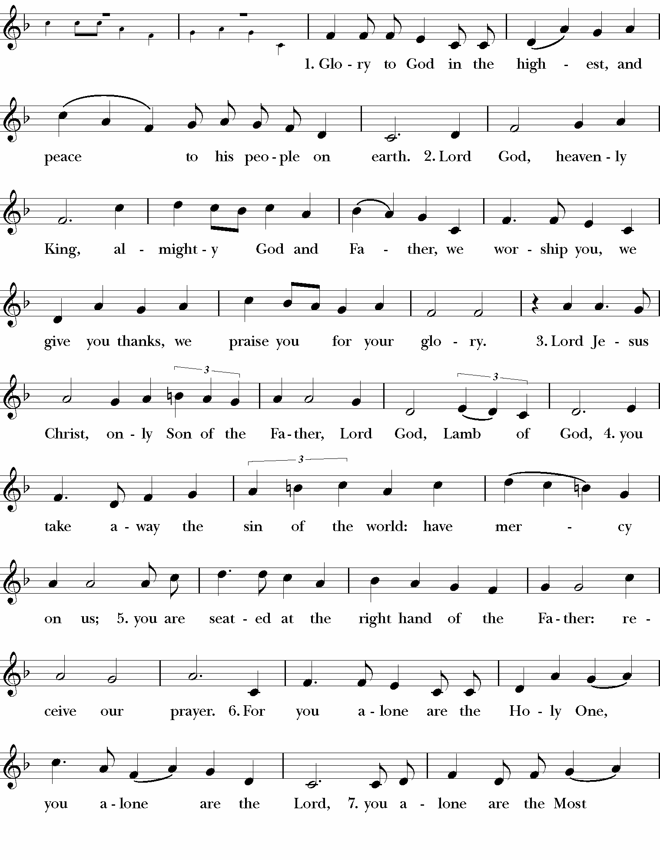

Collect of the Day
Celebrant: The Lord be with you.
People: And also with you.
Celebrant: Let us pray.
Celebrant: Almighty and everlasting God, who in the Paschal mystery established the new covenant of reconciliation: Grant that all who have been reborn into the fellowship of Christ’s Body may show forth in their lives what they profess by their faith; through Jesus Christ our Lord, who lives and reigns with you and the Holy Spirit, one God, for ever and ever. Amen.

Please be seated.

First Reading: Acts 5:27 – 32
Reader: A Reading from the Acts of the Apostles.
When the captain and the temple police had brought the apostles out of the temple, they had them stand before the council. The high priest questioned them, saying, “We gave you strict orders not to teach in this name, yet here you have filled Jerusalem with your teaching and you are determined to bring this man’s blood on us.” But Peter and the apostles answered, “We must obey God rather than any human authority. The God of our ancestors raised up Jesus, whom you had killed by hanging him on a tree. God exalted him at his right hand as Leader and Savior that he might give repentance to Israel and forgiveness of sins. And we are witnesses to these things, and so is the Holy Spirit whom God has given to those who obey him.”
Reader: The Word of the Lord.
People: Thanks be to God.

Psalm 118:14-29
14 The Lord is my strength and my song, *
and he has become my salvation.

15 There is a sound of exultation and victory *
in the tents of the righteous:

16 “The right hand of the Lord has triumphed! *
the right hand of the Lord is exalted!
the right hand of the Lord has triumphed!”

17 I shall not die, but live, *
and declare the works of the Lord.

18 The Lord has punished me sorely, *
but he did not hand me over to death.

19 Open for me the gates of righteousness; *
I will enter them;
I will offer thanks to the Lord.

20 “This is the gate of the Lord; *
he who is righteous may enter.”

21 I will give thanks to you, for you answered me *
and have become my salvation.

22 The same stone which the builders rejected *
has become the chief cornerstone.

Second Reading: Revelation 1:4 – 8
Reader: A Reading from the Revelation to John.
John to the seven churches that are in Asia: Grace to you and peace from him who is and who was and who is to come, and from the seven spirits who are before his throne, and from Jesus Christ, the faithful witness, the firstborn of the dead, and the ruler of the kings of the earth. To him who loves us and freed us from our sins by his blood, and made us to be a kingdom, priests serving his God and Father, to him be glory and dominion forever and ever. Amen. Look! He is coming with the clouds; every eye will see him, even those who pierced him; and on his account all the tribes of the earth will wail. So it is to be. Amen. “I am the Alpha and the Omega,” says the Lord God, who is and who was and who is to come, the Almighty.
Reader: The Word of the Lord.
People: Thanks be to God.

As the cantor begins to sing the Gospel Acclamation, please stand as you are able.
Gospel Alleluia
The Alleluia is sung by a cantor, then repeated by all, then repeated by all again after the gospel sentence.
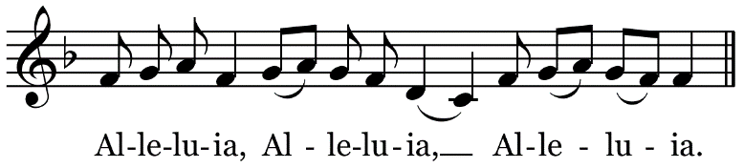

Holy Gospel: John 20:19 – 31
Celebrant: The Lord be with you.
People: And also with you
Celebrant: The Holy Gospel of our Lord Jesus Christ according to John.
People: Glory to you, Lord Christ.
When it was evening on that day, the first day of the week, and the doors of the house where the disciples had met were locked for fear of the Jews, Jesus came and stood among them and said, “Peace be with you.” After he said this, he showed them his hands and his side. Then the disciples rejoiced when they saw the Lord. Jesus said to them again, “Peace be with you. As the Father has sent me, so I send you.” When he had said this, he breathed on them and said to them, “Receive the Holy Spirit. If you forgive the sins of any, they are forgiven them; if you retain the sins of any, they are retained.” But Thomas (who was called the Twin), one of the twelve, was not with them when Jesus came. So the other disciples told him, “We have seen the Lord.” But he said to them, “Unless I see the mark of the nails in his hands, and put my finger in the mark of the nails and my hand in his side, I will not believe.” A week later his disciples were again in the house, and Thomas was with them. Although the doors were shut, Jesus came and stood among them and said, “Peace be with you.” Then he said to Thomas, “Put your finger here and see my hands. Reach out your hand and put it in my side. Do not doubt but believe.” Thomas answered him, “My Lord and my God!” Jesus said to him, “Have you believed because you have seen me? Blessed are those who have not seen and yet have come to believe.” Now Jesus did many other signs in the presence of his disciples, which are not written in this book. But these are written so that you may come to believe that Jesus is the Messiah, the Son of God, and that through believing you may have life in his name.
Celebrant: The Gospel of the Lord.
People: Praise to you, Lord Christ.

Sermon Fr. Jarred
The preacher invokes the Name of the Trinity, all respond “Amen,” and then sit for the sermon.

Please stand as you are able.

Nicene Creed
We believe in one God,
the Father, the Almighty,
maker of heaven and earth,
of all that is, seen and unseen.
We believe in one Lord, Jesus Christ,
the only Son of God,
eternally begotten of the Father,
God from God, Light from Light,
true God from true God,
begotten, not made,
of one Being with the Father;
through him all things were made.
For us and for our salvation
he came down from heaven,
was incarnate of the Holy Spirit and the Virgin Mary
and became truly human.
For our sake he was crucified under Pontius Pilate;
he suffered death and was buried.
On the third day he rose again
in accordance with the Scriptures;
he ascended into heaven
and is seated at the right hand of the Father.
He will come again in glory to judge the living and the dead,
and his kingdom will have no end.
We believe in the Holy Spirit, the Lord, the giver of life,
who proceeds from the Father and the Son,
who with the Father and the Son is worshiped and glorified,
who has spoken through the prophets.
We believe in one holy catholic and apostolic Church.
We acknowledge one baptism for the forgiveness of sins.
We look for the resurrection of the dead,
and the life of the world to come. Amen.

Prayers of the People:
The Celebrant introduces the prayers.

Grant, Almighty God, that all who have passed through the waters of baptism and into your resurrection life may be united in your truth, live together in your love, and reveal your glory in the world.
Silence
Lord, in your mercy
Hear our prayer.

Guide the people of this land, and of all the nations, in the ways of justice and peace; that we may honor one another and serve the common good.
Silence
Lord, in your mercy
Hear our prayer.

Give us all a reverence for the earth as your own creation, that we may use its resources rightly in the service of others and to your honor and glory.
Silence
Lord, in your mercy
Hear our prayer.

Bless all whose lives are closely linked with ours, and grant that we may serve Christ in them, loving one another as he loves us, and dispelling the darkness with the light of his resurrection.
Silence
Lord, in your mercy
Hear our prayer.

Comfort and heal all those who suffer in body, mind, or spirit; give them courage and hope in their troubles, and bring them the joy of your salvation. Among those who have asked for our prayers, we pray for:

Karen Greene

Marie Buckman

Lois Schofield

Mary Snowdon

Laura Hobbs

Jeanne Rainoldi

Richelle Stephens

John Coliano

Ann Davis

Kristin Corning

Silence
Lord, in your mercy
Hear our prayer.

We commend to your mercy all who have died, among those who have died recently, Wendy Colby, William Black, and Bayard Waring, and among those whose anniversaries fall at this time, Lois Blumenscheid, that they may share with all your saints in the glory of Christ’s resurrection.
Silence
Lord, in your mercy
Hear our prayer.

Rejoicing in our fellowship with Blessed Mary, Paul, and all your saints, we offer our whole lives to you and in a moment of silence our own prayers.

Celebrant: Lord Jesus Christ, you said to your apostles, “Peace I give to you; my own peace I leave with you:” Regard not our sins, but the faith of your Church, and give to us the peace and unity of that heavenly City, where with the Father and the Holy Spirit you live and reign, now and for ever. Amen.

Confession & Absolution
Celebrant: Let us confess our sins against God and our neighbor.
Please kneel as you are able.
Silence.
Celebrant & People
Most merciful God,
we confess that we have sinned against you
in thought, word, and deed,
by what we have done,
and by what we have left undone.
We have not loved you with our whole heart;
we have not loved our neighbors as ourselves.
We are truly sorry and we humbly repent.
For the sake of your Son Jesus Christ,
have mercy on us and forgive us;
that we may delight in your will,
and walk in your ways,
to the glory of your Name. Amen.

The Celebrant pronounces God’s absolution and all respond:
Amen.

Please stand.

The Peace
Celebrant: The peace of Christ be with you always.
People: And also with you.

All share signs of Christ’s peace with one another, especially seeking to amend any hurts or conflicts. During this time, all may acknowledge the peace of Christ in and with one another without touch and with a bow from a distance.

THE LITURGY OF THE SACRAMENT
The offering is taken and the altar is set for the Eucharist.
Ascribe to the Lord the honor due the Lord’s name, bring offerings and come into God’s courts.

Please be seated.
Offertory: “Domine Deus” (from Gloria) Antonio Vivaldi (1678-1741)
Jane Niebling, soloist
Lord God of all gods, King of heaven, God the Father omnipotent.

Please stand as you are able.
Eucharistic Prayer
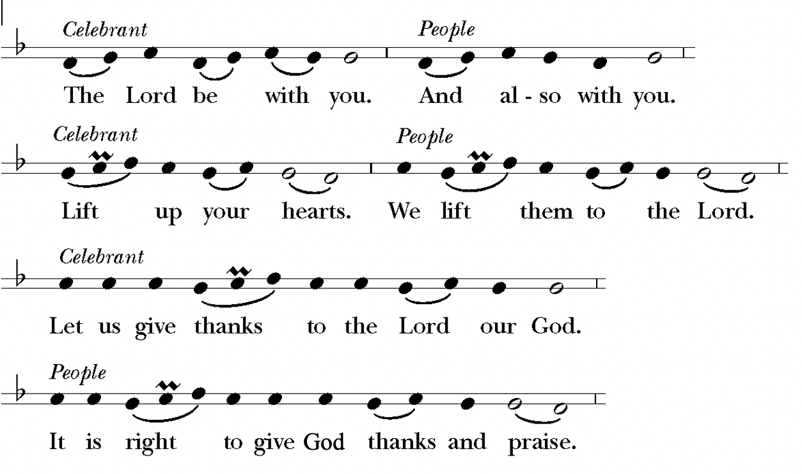
The Celebrant proceeds by singing the Preface to the Eucharistic Prayer, after which all sing the Sanctus
Sanctus: “Holy, holy, holy Lord” S 128 The Hymnal 1982
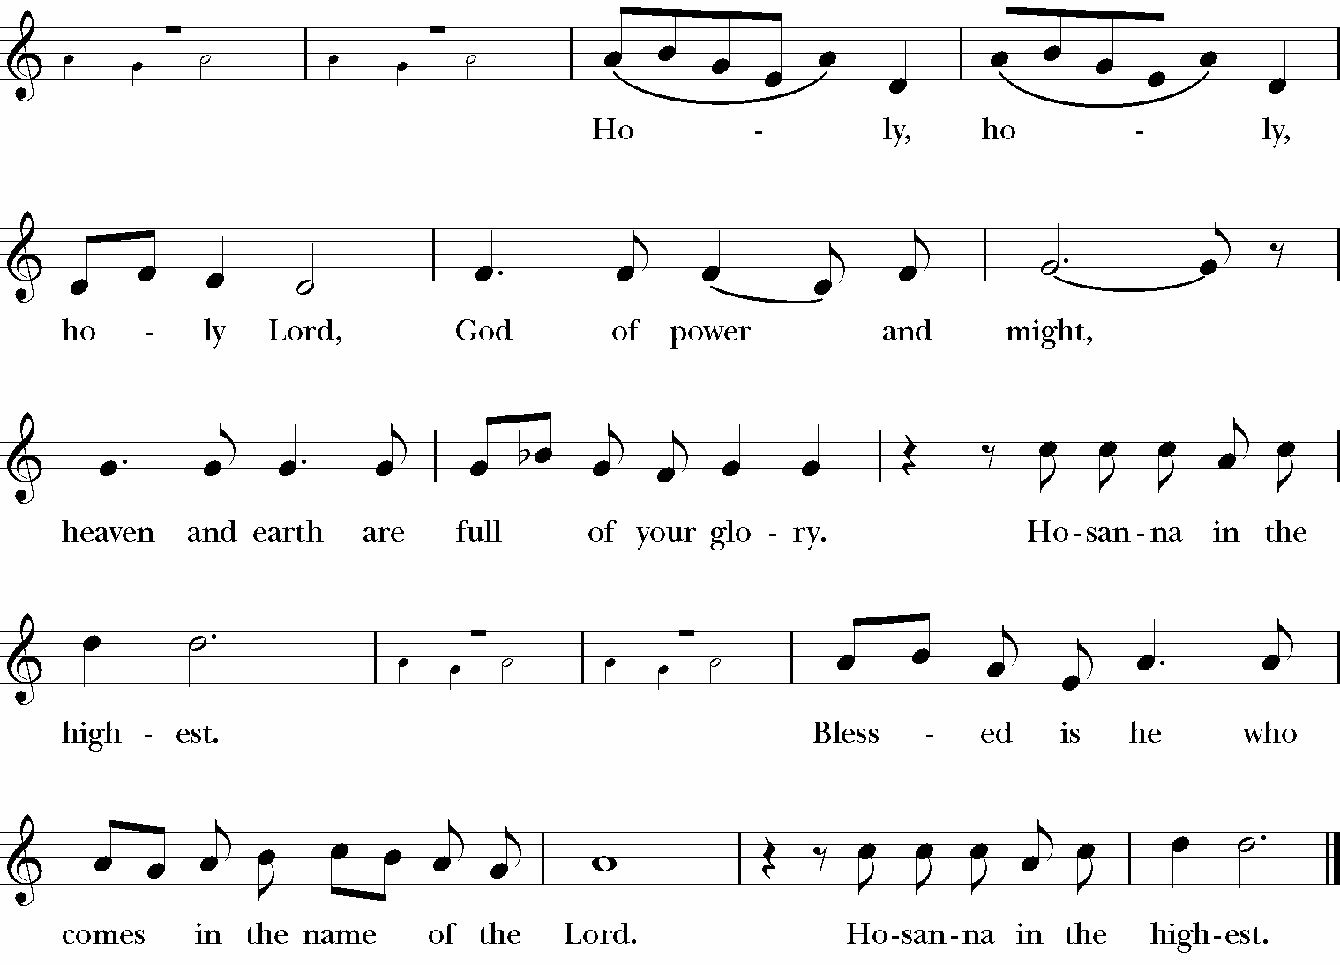

Please kneel as you are able.
The Celebrant continues with the Eucharistic Prayer. After the words of institution this Acclamation may be used:
Therefore we proclaim the mystery of faith: (or)
Great is the mystery of faith:

Celebrant and People
Christ has died.
Christ is risen.
Christ will come again.

The Celebrant continues with the Eucharistic Prayer, leading to the Doxology to which all respond by singing the “great Amen.”
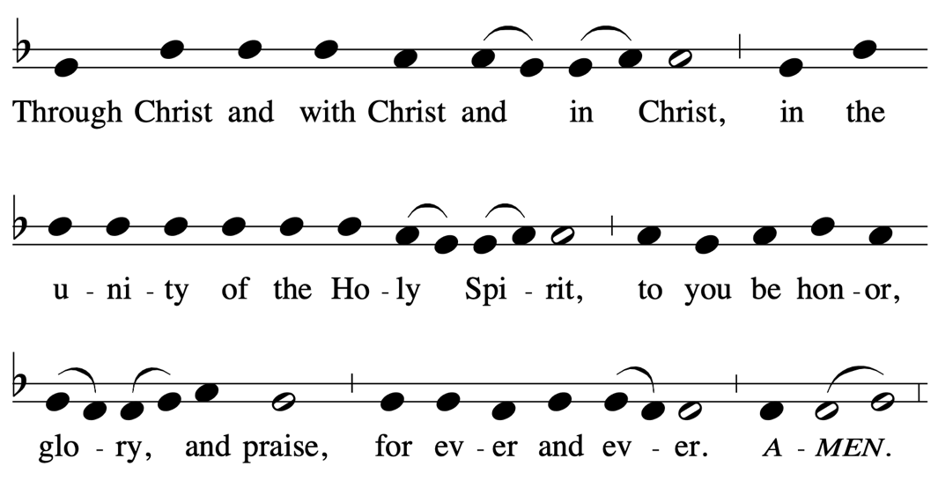

The Celebrant then continues
As our Saviour taught us, now we pray:

Please stand as you are able.
People and Celebrant

Our Father, who art in heaven,
hallowed be thy Name,
thy kingdom come,
thy will be done,
on earth as it is in heaven.
Give us this day our daily bread.
And forgive us our trespasses,
as we forgive those
who trespass against us.
And lead us not into temptation,
but deliver us from evil.
For thine is the kingdom,
and the power, and the glory,
for ever and ever. Amen.

Fraction: The Breaking of the Bread
Celebrant: We break this bread to share in the Body of Christ
People: We who are many are one body, for we all share in the one bread.

Agnus Dei: “Lamb of God” S 163 The Hymnal 1982

Giving of Communion Please kneel as you are able
Celebrant: Alleluia. Christ our Passover is sacrificed for us;
People: Therefore let us keep the feast. Alleluia.

Those present come forward to receive communion, released by pew by an usher. There is no requirement to be a member of St. Paul’s or Episcopalian to receive communion here. We believe that all are welcome, regardless of tradition or denomination, to be nourished at Christ’s table and strengthened to live the faith of their baptism. If you wish to receive a blessing rather than communion, please cross your arms over your chest as a sign of this.

If you would like communion brought to your seat, please let your usher know.

We are now receiving communion in both kinds (bread and wine). If one wishes to receive the bread only due to the pandemic, this in no way diminishes the sacrament. It has always been the teaching of the Church that the whole Christ is present to us whether we receive both bread and wine together or only one. Intinction (dipping bread into the wine) is not allowed.

Please take a sip from the common cup to receive. If you are not receiving the wine, cross your arms over your chest in front of the chalice after receiving the bread an acknowledge Christ’s presence with us by saying “Amen” after the chalice bearer says, “the blood of Christ.”

All remain kneeling as they are able upon returning to their seats after communion.
Prayer of Spiritual Communion
Those unable to be present who are worshiping with us at a distance may pray this prayer of spiritual communion:

Jesus, I believe that you are truly present in the Blessed Sacrament of the Altar. I love you above all things, and long for you in my soul. Since I cannot now receive you sacramentally, come at least spiritually into my heart. As though you have already come, I embrace you and unite myself entirely to you; never permit me to be separated from you. Amen.
(St. Alphonsus de Liguori, 1696-1787)

All remain kneeling as they are able upon returning to their seats after communion.

Communion Hymn: “Alleluia, alleluia! Give thanks to the risen Lord” #178 The Hymnal 1982
All sing the refrain; a soloist will sing the verses.
Elaine Bucher, soloist; Nancy Jukins, guitar
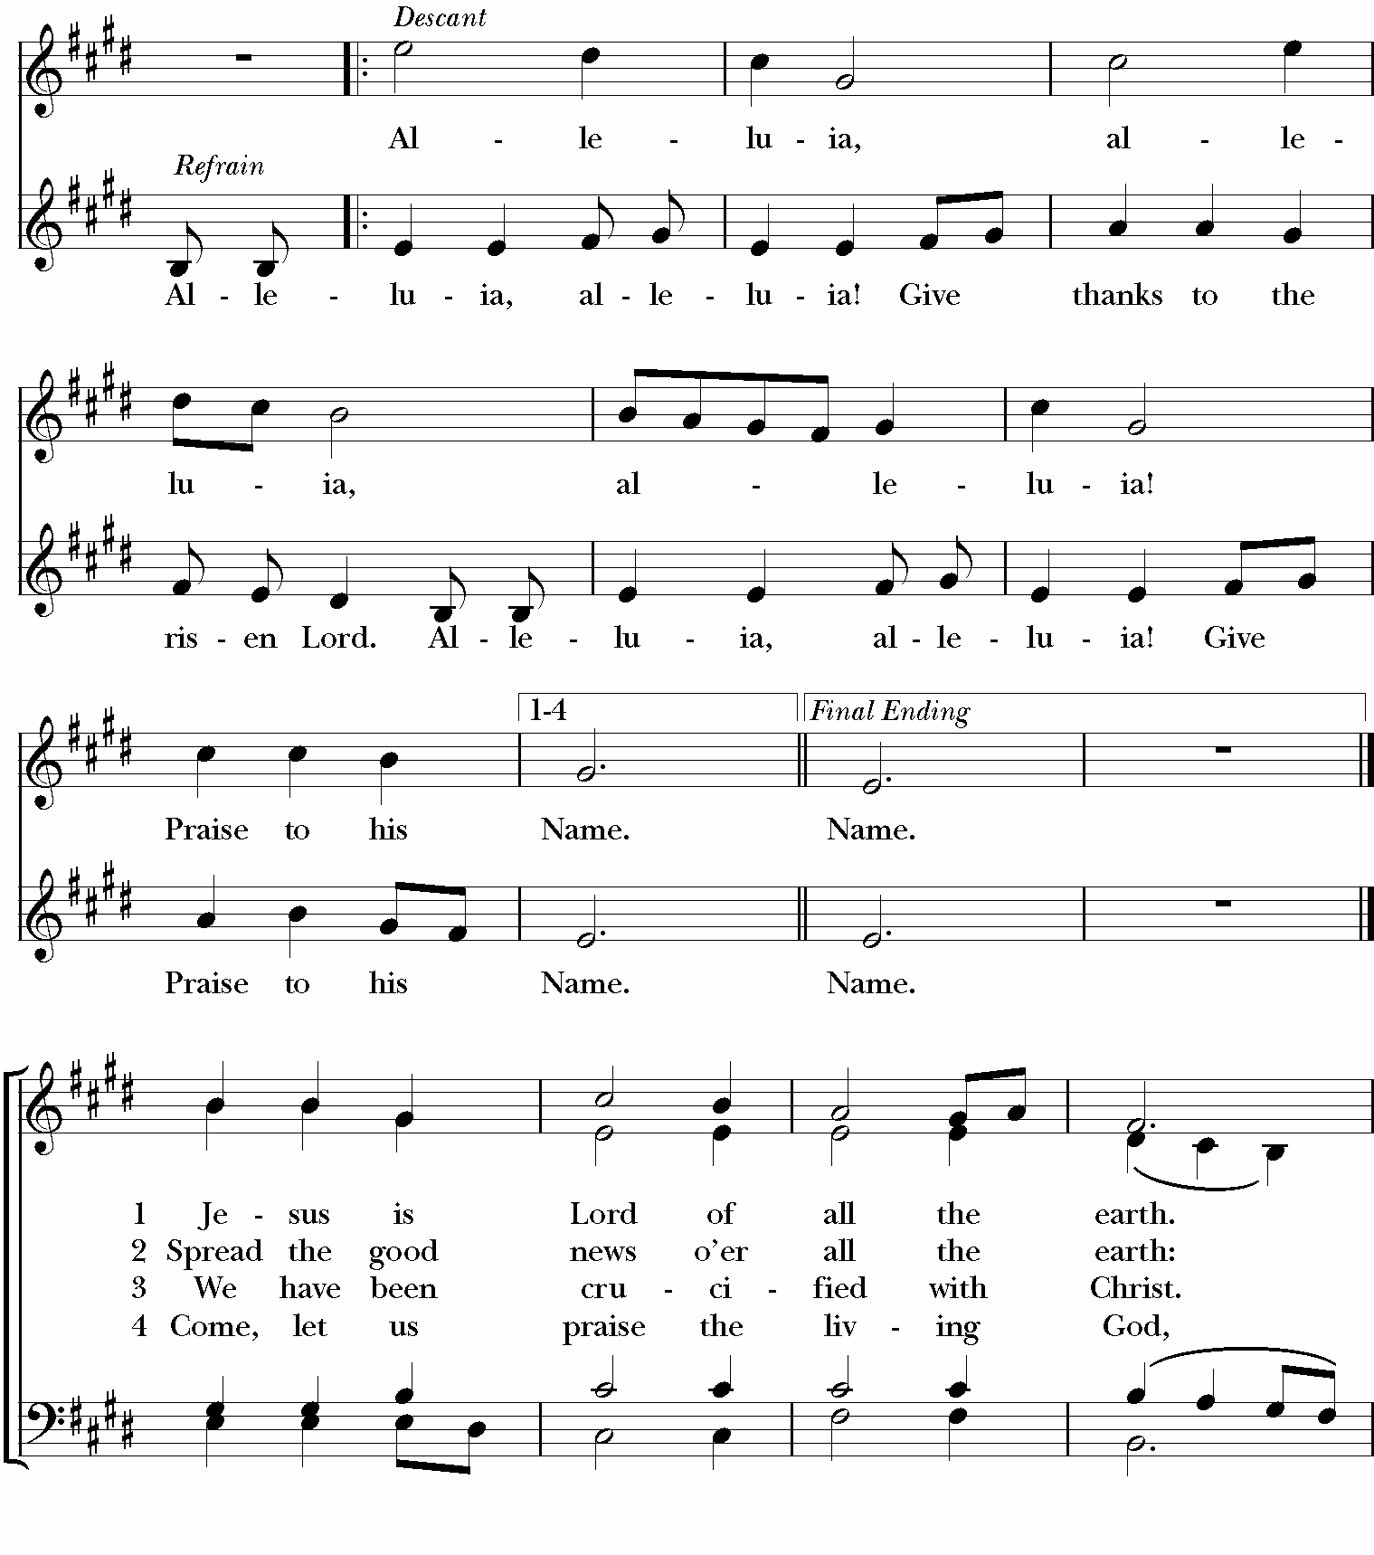
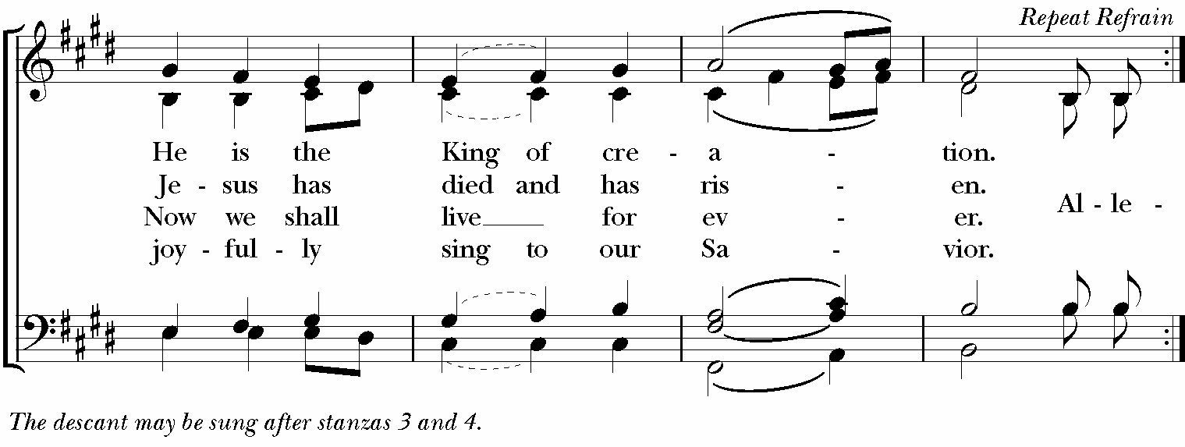
After communion the Celebrant continues:
Let us pray.
Please stand as you are able.
Celebrant & People
Eternal God, heavenly Father,
you have graciously accepted us as living members
of your Son our Savior Jesus Christ,
and you have fed us with spiritual food
in the Sacrament of his Body and Blood.
Send us now into the world in peace,
and grant us strength and courage
to love and serve you
with gladness and singleness of heart;
through Christ our Lord. Amen.

Blessing
Celebrant: The Lord be with you.
People: And also with you.

The celebrant pronounces a blessing, after which all respond
Amen.

Dismissal #175 The Hymnal 1982
The Celebrant sings the Easter dismissal, and all sing the response:

Closing Hymn: “O sons and daughters, let us sing” #206 The Hymnal 1982
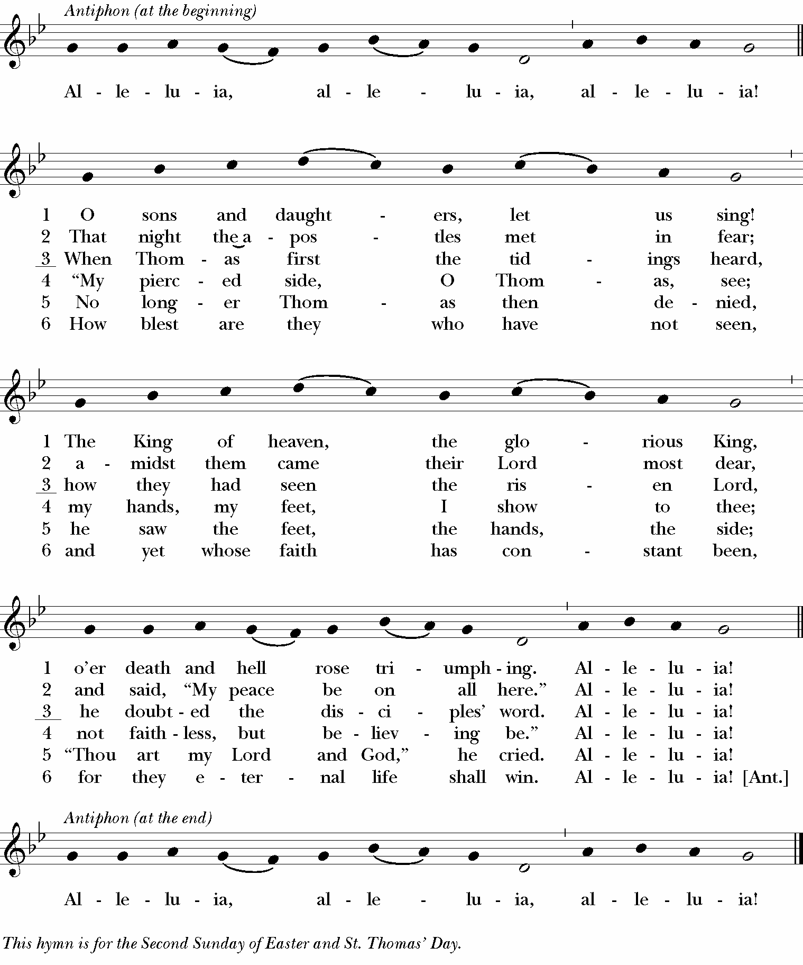

Postlude: “Come, ye faithful, raise the strain” organ setting by Jon D. Vieker (b. 1961)

+++
Today’s Service Leaders
Clergy: The Rev. Dr. Jarred A. Mercer
Music Director: Mark Meyer
Choir: Terry Anderson, Richard Blumenscheid, Elaine Bucher, Karen Caplan, Joyce Cejka,
Pam Jones, Jane Niebling
Lay Eucharistic Minister: Tom Hussey
Lectors: Frank Condella

ANNOUNCEMENTS
Worship Services
Sunday 9:00 am Parish Eucharist in person and livestreamed on YouTube https://www.youtube.com/c/StPaulsChurch-NewburyportMA/live.
Wednesdays: Holy Eucharist at noon. Wednesday Eucharist will return on May 4.
Prayers for healing and wholeness are offered at the 9:00AM Sunday Eucharist during communion in the side chapel.

Formation Hour
Formation Hour takes place in the church from 1015AM to 11AM with the opportunity for adults and children to go deeper in our faith, wrestle with questions and doubts, and grow together as a community. No formation hour this week, will return next Sunday, May 1.

The Rule of Five: A Workshop for Lectors
Saturday, May 7, 9:00AM to Noon at St. Paul’s Church in the Chancel. However well you read, there’s more to reading Scripture than just reading it. In this workshop, we look at your role as Lector as well as preparing to read. We address how to read and how to pronounce the unpronounceable. How do you say ‘Eli Lama Sabachthani’ anyway? We’ll then work with a passage using the Rule of Five. After this, you’ll be ready, almost, to read your passage from memory with understanding. To register, please call Bob Keller, 978-465-5111, or email to rk2name@gmail.com.

Among Friends Needs Drivers! Can you Help?
Meal delivery drivers are needed on Tuesdays and Fridays between 11 am and 12 noon. You will only be scheduled twice a month. Please contact Deb Hay at the church office if you are interested. Thanks!

Lay Eucharistic Visitor Training
Are you interested in becoming a Lay Eucharistic Visitor? This ministry enables you to take communion to the homes of our members who are unable to attend our services. If so, there are steps that must be completed to become a Lay Eucharistic Visitor and licensed by our Bishop.
- First, speak to Fr. Jarred about your interest.
- Complete Lay Eucharistic Visitor training provided by our Diocese. The training will be led by Becky Alden and Rev. John Conn.
- Attend the next ZOOM training session scheduled for Saturday, April 30, 9:30 am
to 3:00 p.m. with an hour lunch break.

Click on the Diocese of Massachusetts website for additional information and to find the Lay Eucharistic Visitor training registration and licensing application at: www.diomass.org/resources/training_learning_opportunities/eucharistic-visitor-training

Copyrights:
Prelude from Ten Hymn Introductions, Set 2 by Michael Burkhardt. Copyright @2001 Birnamwood Publications, Sole Distributor MorningStar Music Publishers of St. Louis, Fenton, MO. All rights reserved.
Prelude from Easter Mosaics by Jacob B. Weber. Copyright @2014 Concordia Publishing House, St. Louis, MO. All rights reserved. Music: Copyright @1973, and this arr. @2014, International Liturgy Publications, Nashville, TN. All rights reserved. International copyright secured.
Hymn 200 from The Hymnal 1982. Words and music: public domain.
Gloria S-280 from The Hymnal 1982: Words: public domain. Setting copyrighted by The Church Pension Fund, New York, NY.
Gospel Acclamation from Gather Comprehensive 158. Music: Chant Mode VI; acc. by Richard
Proulx, @1985, GIA Publications, Inc., Chicago, IL.
Offertory from Gloria by Antonio Vivaldi. @1985 Roger Dean Publishing Co. Division of Heritage Music Press, Dayton, OH. All rights reserved.
Sanctus S-128 from The Hymnal 1982: Words: public domain. Setting @1976, Oxford University Press, Inc.
Agnus Dei S-163 from The Hymnal 1982: Words: public domain. Setting copyrighted by The Church Pension Fund, New York, NY.
Hymn 178 from The Hymnal 1982. Words: Copyright @1973. The Word of God, Ann Arbor, MI. All Rights Reserved. Music: Melody copyright @1973. The Word of God, Ann Arbor, MI. All Rights Reserved.
Easter dismissal S-175 from The Hymnal 1982: Words and music: public domain.
Hymn 206 from The Hymnal 1982. Words and music: public domain.
Postlude from Hymn Prelude Library, Volume Four, edited by Kevin Hildebrand. Copyright @2013 Concordia Publishing House, St. Louis, MO. All rights reserved.

Reprinted / streamed with permission under OneLicense number: 711320-A
All rights reserved.
Valid for: 03/18/2022 – 03/17/2023

Cycle of Prayer
Today as we worship we keep in our prayers the Parishes of the Concord River Deanery
St. John’s Chapel, Groton School, Groton; St. Michael’s Church, Holliston; St. Paul’s Church, Hopkinton; St. Luke’s Church, Hudson; Episcopal Church Women, and in the local cycle of prayer: Star of the Sea Church, Salisbury.

Prayer List

Allison Flynn

Eve Steinberg

Judy Abby

Debby Demopoulos

Marya Toffey

Stephen Mathis

Talia Duff

Stephen Jones

Betty Moberger

Tony Broer

Joanne Norris

Karen

Theresa Winslow

Oli Braids

Karen Greene

Marie Buckman

Lois Schofield

May Snowdon

Laura Hobbs

Jeanne Rainoldi

Richelle Stephens

John Coliano

Ann Davis

Kristin Corning

Nancy Burkholder

Jori Guldenstern

Rev. Connie Reinhardt

Tim Coco

Barbara Barnes

Alexander Wood

Corey

Kathy Steele

Karen Staffeld

George Partaledis
Jane Robinson
Peggy Dunlap
Allison Ballentine

Paul Lucas

Karen Caplan

Jane Ellis

Jim Reid

Nick Varoutsos

Cara O’Reilly McCabe

Kathy Wheaton

Wendy Colby

Rachel Perry

Kristen Thayer

David Yates

Kathy Loughlin
Jess & family

Katie, Brian & family

Frances and John Fleming

Jake

Lindsey Leitko

Anita & Diana

Jud Porter

Sue Wilcox

Priscilla Janvrin

The Dunphy Family

Paul Mendez

Corrine Languedoc

Wayne Sanborn

Chet Brown

Paul Thiefels

Lisa Ransom

Susan S.

Mark B.

Linda T.

Abby Reese

Bob Northam

Jud and Barbara Porter

Sondell Ayala

Susan Russell

Pam

Sue Skinner-Kidd

Rose O'Neill

Marilyn Sell

Becky Piecewicz

Ruth Pinkham Haring/Family

Tracy Broderick

Anthony DiBona

Michelle Mendez

Covid Protocols

For those who are fully vaccinated, masks are optional and encouraged based on one’s needs and comfort. Masks are required for those who are unvaccinated.

The pews at front left of the church are reserved for those who wish to stay socially distanced during the service.
- We are now receiving communion in both kinds (bread and wine). If one wishes to receive the bread only due to the pandemic, this in no way diminishes the sacrament. It has always been the teaching of the Church that the whole Christ is present to us whether we receive both bread and wine together or only one element.

Addition Easter Flower Remembrances
William Black
Paul Sullivan

St. Paul’s 2022 Vestry

Deirdre Budzyna – Senior Warden

Vacant – Junior Warden

Nick Ives – Treasurer

Susan Aquaviva – Clerk

Shepherds

Class of 2025

Pam Jones

Class of 2024

Lorrie Jones

Lisë Reid

Class of 2023

Kerry Lagueux

John Neale

Alison Novello

Diocesan Delegates/Deanery Representatives
Alison Novello, Lainie Ives

St. Paul’s is a parish of the Episcopal Diocese of Massachusetts

Our bishops are: The Rt. Rev. Alan M. Gates and The Rt. Rev. Gayle E. Harris

St. Paul’s Staff

The Rev. Dr. Jarred A. Mercer, Rector – rector@stpaulsnewburyport.org

Mark Meyer, Music Director – markmeyer49@gmail.com

Deb Hay, Office Manager – stpauls@stpauls-nbpt.org

Office: 978-465-5351

Office Hours

Monday – Wednesday 8AM – 4PM, Thursday – Friday 8AM – 2PM

Websites

Diocese of Massachusetts www.diomass.org St. Paul’s Church www.stpaulsnewburyport.org

